Thin layer chromatography (TLC)
Report 1
Student’s Name
Institution Affiliation
October 10 2018

Thin layer chromatography (TLC)
Introduction
TLC is a technique of chromatography that is used in the separation of volatile mixtures. The experiment is usually performed on a sheet of plastic, glass or aluminum foil that has been coated with a thin layer of adsorbent materials usually aluminum oxide, silica gel or cellulose. The components of a mixture are separated using thin plates that have been supported by an inert backing. The experiment is performed at an analytical scale to purify small quantity of a compound or monitor progress of a reaction (Kaur, Wakode & Singh, 2016). The overall objective of this experiment remained to obtain well separated, well-defined spots and then calculate the retention factor on the basis of the distance migrated over the distance covered by the solvent (Oberlerchner et al, 2018).
Materials
The apparatus needed for this experiment included: Micropipettes, Pre-coated TLC plates, Developing chamber, 95% ethanol, burners, Pencil, visualizing UV light source, developing solvent and motors.
Procedure
Drew out 8 Micropipettes from open end capillaries. Then obtained two pre-coated TLC palates while handling them by their edges. Prepared a developing chamber using a beaker 000ml beaker that that was then covered by a foil and contained a single paper towel along its outside edge. 10mls of the developing solvent was poured into this chamber. Ground each analgesic table into a powder using a mortar then added 5 millimeters of ethanol into each power while in the mortars before powering it into a large test tube gently. Simmered the resulting solution slowly for about five minutes in a 600 ml beaker in order to extract its organic ingredients. Drew a line about 1 cm from the bottom of one TLC palate and labeled three equally spaced Xs before applying samples and mixtures from the analgesics extracts directly on the Xs using the clean micropipettes. Once the solvents had evaporated, the spots become invisible but they could be visualized under a 250nm UV light. Three samples of known ingredients were then applied on the second TLC palate using the same technique. The two palates were them placed into a developing chamber ensuring that they did not touch each other or the filter paper strip. The plates were removed an allowed to evaporate in the hood once the solvent had risen to within one centimeter of the top of the plate. The solvent front line was marked. Afterward, the spots were visualized under UV light and spots outlined with a pencil. The distance traveled by each component and the solvent front line were measured to the center of each spot and the Rf of each spot computed thereafter.
Results
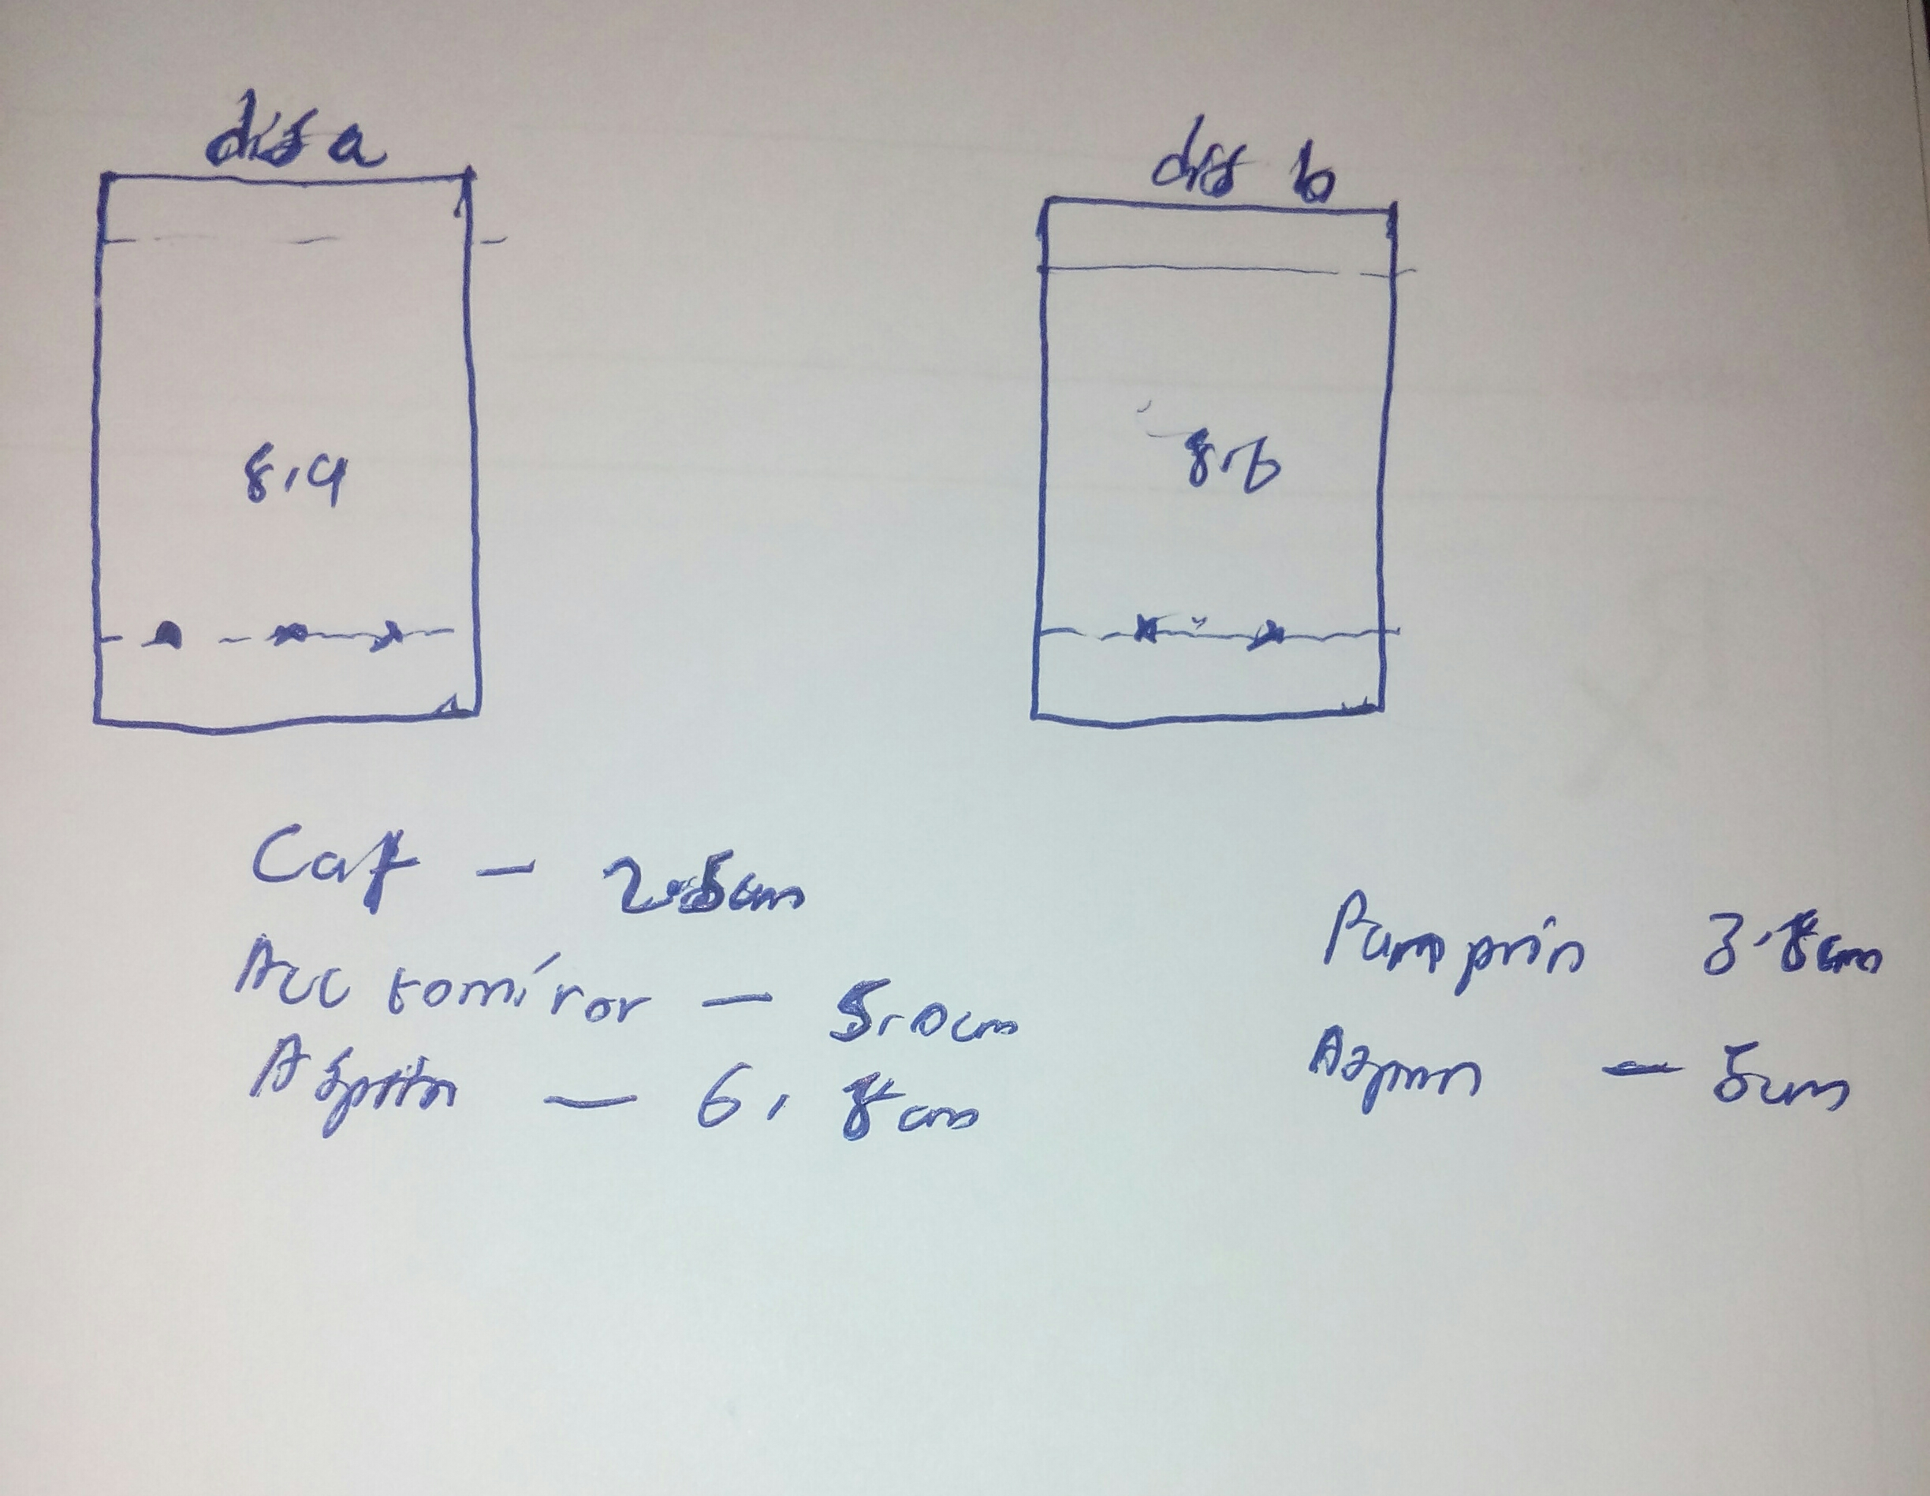
Retention factor calculation (Rf)
Rf = distance travelled by the sample/ distance travelled by the solvent
Dis a | Dis b
Rf for caf =2.5/8.9 = 0.281 | Rf for panprin = 3.8/8.6 = 0.442
Rf for Acctomiror = 5.0/8.9 = 0.562 | Rf for aspirin = 5/8.6 = 0.582
Rf for aspirin = 6.8/8.9 = 0.764

Actominor most likely contains aspirin

Discussion questions
The reason why polar and nonpolar compounds area eluded by polar solvents but only non-polar compounds solvents eluded by non-polar solvents lies in the energy requirement needed to break inter-molecular forces between molecules in the solvent and solute. In non-polar substances, there are dispersion forces that exist between each molecule. These forces are relatively weak and thus only require a small amount of energy to break while in polar substances, depending on the substance, there are hydrogen bonds and dipole forces between molecules. These forces are relatively stronger thus require more energy to break. It is important to note that for both non-polar solutes and polar solvents (and vice versa), both the dipole forces and dispersion forces need to be Brocken but this needs a lot of energy but the molecules in the solvents and solute are only able to form dispersion forces with each other. Thus since the overall energy required is greater than that released, the process does don occur.
Results of error in TLC vary considerably depending on the cause. When the solvent in the developing chamber is too deep, the sample will travel too far leading to incorrect conclusions. When the solvent front is allowed to rise only halfway up the TLC plate, this level may be lower than that needed by some solutes, thus the actual retention factor cannot be assessed. When the solvent polarity is too high, this would move all the molecules to the top of the TLC and this is not desired. When the solvents polarity is too low, all the compound would not move if they are polar. When faint spots are applied at the origin, it will be difficult to track the different compounds as they rise up the TLC plate. It will thus be difficult to discern the compound under study.
The active ingredient in the unknown analgesic according to the results of the experiment is aspirin. This is based on the comprising of the retention factor for the two TLC plate results. This ingredient is appropriate for its intended purpose. This is because aspirin is an NSAID which are known to relieve pain without necessarily leading to loss of consciousness or without the need of anesthesia.

IF Benzene Ph-CH2OH, Ph-COOH, PhCOCH3, PhCH2CH3, PhCH3
Differences if ethanol was used in place of benzene
If alcohol PhCH3, PhCH2CH3, PhCOCH3, Ph-COOH, Ph-CH2OH

Conclusion
TCL is a chemistry technique that is very useful. It a method that has very many uses such as the detection of compounds present in a mixture, the establishment of whether twos compounds that have different origins are actually similar, and detection of the number of compounds present in a mixture (Poole, 2014). Thus TCL can help within a short period of time to determine the identity or composition of a compound as demonstrated in the experiment. The experiment has shown that the active ingredient in Actominor is actually aspirin (Reich, Frommenwiler & Maire-Widmer, 2015).

References
Kaur, I., Wakode, S., & Singh, H. P. (2016). Development and validation of a stability-indicating high performance thin layer chromatography (HPTLC) method for estimation of canagliflozin in bulk and pharmaceutical dosage form. Journal of Applied Pharmaceutical Science, 6(5), 051-057.
Oberlerchner, J. T., Fuchs, C., Grausgruber, H., Potthast, A., & Böhmdorfer, S. (2018). À côté calibration–Making optimal use of time and space in quantitative high performance thin layer chromatography. Journal of Chromatography A, 1533, 193-198.
Poole, C. (2014). Instrumental thin-layer chromatography. Elsevier.
Reich, E., Frommenwiler, D. A., & Maire-Widmer, V. (2015). High-performance thin-layer Chromatography for the Identification of botanical Materials and the Detection of Adulteration. In Botanicals (pp. 258-277). CRC Press.

